WATER LEVEL MONITORING SYSTEM

 | Kumudini Thote |  |  |  |  |  | Ruchira Thete
Department of Computer Science |  |  |  |  |  | Department of Computer Science
 | Binghamton, New York |  |  |  |  |  | Binghamton, New York
kthote1@binghamton.edu |  |  |  |  |  | rthete1@binghamton.edu
​Abstract |  |  |  |  | I. | INTRODUCTION
 |  |  |  |  |  | ​

Approximately 71percent of Earth’s surface is water-covered, and oceans holds about 96.5 percent of all Earth’s water. From that only 2.5 percent can be used to drink. So as human being we must save the water. One of the major problems faced by most of the countries is the issue of water scarcity and wastage during transmission has been identified as a major culprit; these are the motivations for this research, to deploy computing techniques in creating a barrier to wastage in order to not only provide more financial gains and help the environment as well as the water cycle which in turn ensures that we save water for our future. IOT based Water Level Monitoring system is an innovative system which will inform the users about the level of water and will prevent it from overflowing. This paper proposes an advanced water management system, where the ultrasonic sensors placed over the containers to detect the liquid level and compare it with the container’s depth. The system makes use of Arduino uno 3, Wi-Fi modem. Thus, this system helps to prevent the wastage of water by informing about the liquid levels of the containers

Keywords

Arduino uno 3, Ultrasonic sensor, Water tanks, Esp8266 wifi module, Server for database, GSM Module, Web application
Water is very precious and important aspect of everyday activity; hence conservation is very important, otherwise adverse effects can be seen. Storage of water for domestic, industrial, agricultural, or other such needs is especially important. Safe drinking water is becoming more polluted and injurious due to increasing population and their greedy demands for urbanization, industrialization, and so on‭.‬ ‭At the household level, some people turn-on the electric water-pumps ‬and set off to work or even go to sleep, neglect to turn-off the mains when the water container is full. Thus, the need for a continual and dependable water supply is important for ones needs. This thesis focusses on contribution of an IoT depended solution for every single issue ‭ ‬mentioned previously.‬

IoT is playing major role in the field of environmental monitoring especially in the disaster management, early warning systems as well as environmental data analytics. A big challenge in the urban cities is that of water management as there is a rapid growth in the rate of urbanization and thus there is a need for sustainable urban development plans. To avoid all such situations, we intend to propose a solution for this problem "Water Level Monitoring system”. In this paper, we proposed an IoT based water monitoring system in the real time scenario. The sensors in the system measure the level of the water in the tank and data is sent through the cloud server. The user can view the data on the remote dashboard. This system may be used equally efficiently by homeowners as by industrial users and other water utilities.

  - C​OMPONENTS

- Ultrasonic sensor:

An Ultrasonic sensor is a device that can measure the

distance to an object by using sound waves. It measures distance by sending out a sound wave at a specific frequency and listening for that sound wave to bounce back.
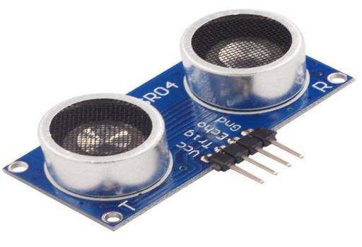

B. Arduino microcontroller

Arduino is an open-source platform used for building electronics projects. Arduino consists of both a physical programmable circuit board (often referred to as a microcontroller) and a piece of software, or IDE (Integrated Development Environment) that runs on your computer, used to write and upload computer code to the physical board. Secondly, Arduino does not need a separate piece of hardware in order to load new code onto the board – you can simply use a USB cable. Furthermore, the Arduino IDE uses a simplified version of C++, making it easier to learn to program.
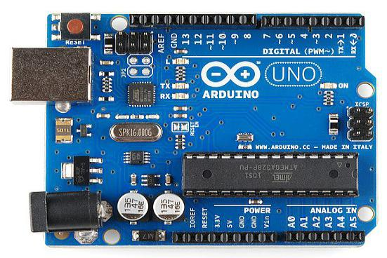
C. ​Breadboard and Jumper wires:
​A breadboard is a construction base for prototyping of electronics. "Breadboard" is also a synonym for "prototype". Because the solderless breadboard does not require soldering, it is reusable. This makes it easy to use for creating temporary prototypes and experimenting with circuit design. A variety of electronic systems may be prototyped by using breadboards, from small analog and digital circuits to complete central processing units (CPUs). In our scenario we have used a breadboard for connecting wires. We have used jump wires also called jumper wires. In our system, Jumper wires are used for making connections between items on your breadboard and Arduino header pins.
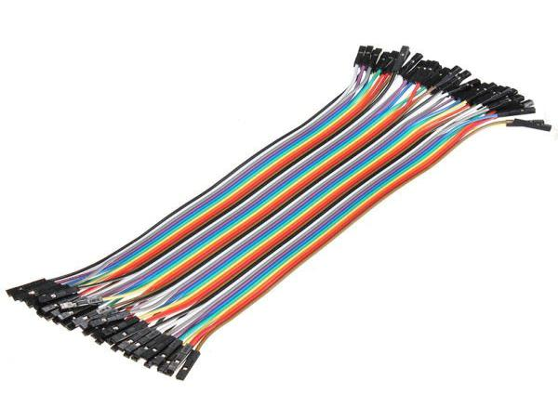

E. Serial wifi wireless transceiver module:

​ESP8266 is a chip which is a wireless network microcontroller module. It will be a system-on-a-chip (SoC) with capabilities for 2.4 GHz Wi-Fi, general-purpose input/output etc.
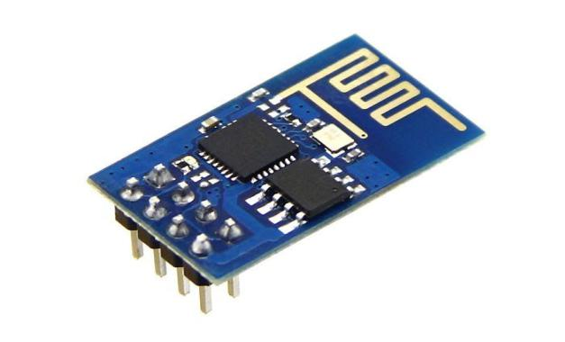
F. GSM Module:

GSM Module is a SIM 900a module built with dual band GSM/GPRS. It works on frequencies ranging from 900/1800 MHz. The frequency bands can be set by AT commands. The baud rate is configurable from 1200-115200 through AT commands. The GSM/GPRS module has an internal TCP/IP stack to enable you to connect and communicate with the internet via GPRS which helps in sending SMS or make calls.
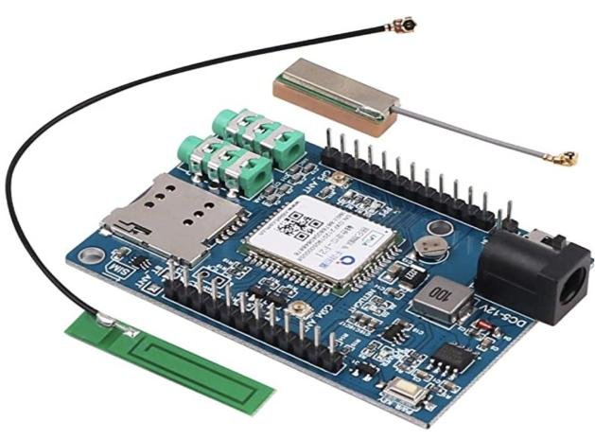

- A​RCHITECTURE
To achieve a system for water monitoring, we have used components such as ultrasonic sensors, microcontrollers, as explained above which are capable of notifying water level status. In our system the sensors placed in the tank sense the level of the water in that tank. On reaching the threshold a command is generated through which the authorized person will come to know about the location of tank which is about to get filled. The authorized person conveys this notification to the machine controller with the help of an android application. The architecture can be clearly understood with the help of the below figure.

According to the figure, the Ultrasonic sensors sense the water level of the tank and sends it to Arduino board. From there the data is send to the data base so that person monitoring the application can see the status at any given time. Whatever data has been displayed, shows the current status of the tank. A message can be sent to the controller regarding the status of tank when it is about to overflow, or water level is below stated.

In the cloud, we can make an analysis of how much time the water was overflowing if it does, how much electricity consumption can be done and how many liters of water that area is using. which can help the authority with better strategies for water management. The proposed architecture assumes a backup server be provided by the cloud service provider. Along with the real time analysis, the optimized route to reach at the tank if machine fails to start or stop. This will provide the advantage of saving fuel costs. The authority would view all the reports, optimized routes and all the data related to the tanks. The accordingly we can direct the person controlling the machine and make efficient plans for the water management.
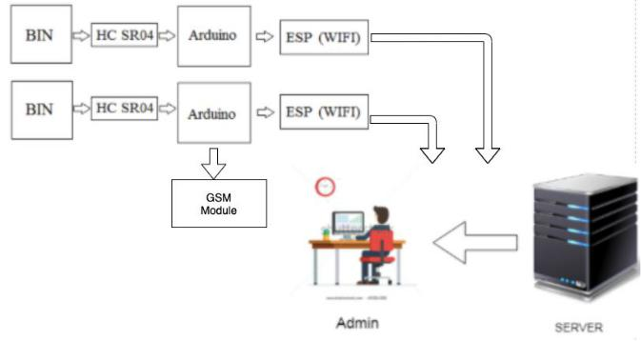

IV. I​MPLEMENTATION​ M​ETHODOLOGY: ​

A. Hardware components implementation

For this model, every tank has given a unique id. Database will contain the location of the tanks along with their corresponding ids. The tank will have an ultrasonic sensor from which the level of water can be detected. Ultrasonic sensors are used to detect the level of the water in the tank. The water level sensor is made with an ultrasonic sensor mounted on the top of reservoir. As we know that Ultrasonic sensors generate high frequency sound waves and evaluate the echo, which is received back by the sensor, measuring the time interval between sending the signal and receiving the echo to determine the distance to an object. In this case, the object is the water, and the sensor is used for measuring the level of tank. The level of water calculated is between the sensor and water level int the tank.

For this model, the arduino is the microcontroller which will be programmed in such a way that it would control the power from being wasted. In detail, monitoring the tank at every interval will lead to wastage of power and energy through sensors. Therefore, the sensors will be activated only after certain intervals of time so that the power could be saved. The information collected by the sensor will be processed by an arduino microcontroller. Hence saving energy and power is the main work of an arduino microcontroller.

B. Admin Implementation

From the collected data, the admin will get to know about real-time water level. Admin has responsibility to add any new tank at new locations which is used to run and maintain this system efficiently.

For this admin there is a web dashboard in which admin has access to information about the level of water in all the tanks and the updated tank information is done using this web portal.

This web portal is made using html, javascript, jquery and bootstrap for client side processing and php for server side processing. Database is implemented using mysql.

C. Location Optimization

Google Api’s are used in our application for Locator Optimization.

Locator Application is used for seeing the overview of all the tank and adding any new tanks.

- I​MAGES​​OF​I​MPLEMENTATION
Location Generation:
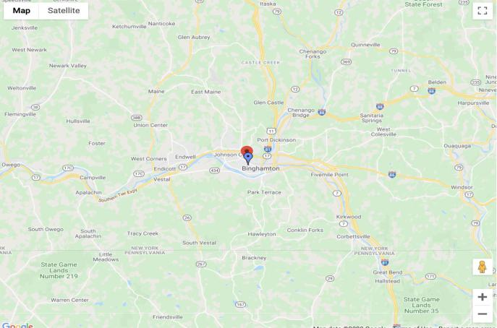
Circuit Diagram:
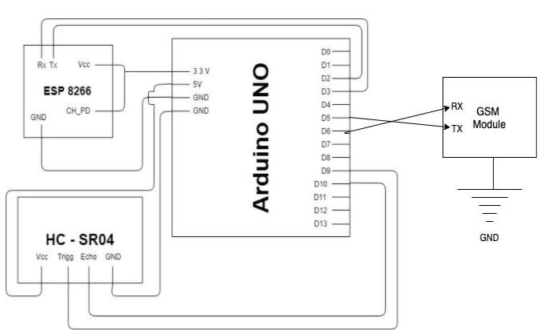

VI. FUTURESCOPE

In future, the proposed system can be used to monitor and analyze water usage of the specific water source thus require developing such logic for the application. The system can also be used to collect and study the environmental data of water source and its surrounding area by integrating other sensor to the system. The study may include location data, water quality, temperature, humidity and various other factors. For example, Arduino GPS shield can be integrated in the system to obtain location data of the water source dynamically.
• Power conservation.
• Automatic on/off switching operation.
• Wireless Communication.
• Can be implementing on any water source.
• Accuracy.
• Mobile Access.

VII Advantages
• Cost effective.
• Practical and affordable.
• Pollution free and the safest way to save energy.
• Reduces human resource and provides security.
• Ensure security.
• lower maintenance.
• Easy to use.
• Easily available and replaceable components.

VIII. APPLICATION:

Can be implemented in any water resources like ponds, lakes, rivers or even household applications such as tanks or even government reservoirs such as metro water tanks, Lorries through which we can monitor the level of water evaporation and reduce it through necessary steps.

IX. C​ONCLUSION

This paper shows the implementation of water monitoring system using ultrasonic sensor, arduino microcontroller, and other required components. This system ensures that water supply is done promptly and efficiently without wasting water.

This Project aims for the betterment of city and technology solutions are provided to manage the waste of water in a cost-effective manner by saving the fund for collection and transportation. The information is processed with very less human intervention, the collection of levels and storing and generation of routes is done automatically therefore there is less chance of error. Google provides the best algorithm for the route optimization and navigation for the optimized path.

Therefore, our System improves the monitoring system which reduce. Monitoring water from remote location may be very useful when it is not possible to visit location physically every time.

R​EFERENCES

- Murkar Santosh, Naik Anjali, Patankar Bhakti
“Water Level Monitoring and Dam Gate Control over IOT” International Journal on Future Revolution in Computer Science & Communication Engineering Volume: 4 Issue: 4

- Anton Prafanto, Edy Budiman “A Water Level Detection: IoT Platform Based on Wireless Sensor Network” EIConCIT 2018
- Jemy Joseph, Manju K M, Sujith Nair, Vishnu P Vijay, Sitara Krishnan, “Water Managemnent System Using IoT”, IRJRT Volume 05 Issue 04 Apr

- Mohita Parashar, Roopa Patil, Sidharth Singh, Vipul VedMohan, K. S. Rekha “Water Level Monitoring System in Water Dispensers using IoT”, International Research Journal of Engineering and Technology –Volume5 Issue4 – Apr 2018

- Thinagaran Perumal, “Internet of Things Enabled Water Monitoring System”, Global Conference on Consumer Electronics 2015

- Neeraj Gupta, Allan Sasi, Ayush Deep, Jaekeun Lee, Daebeom Jeong, and Sehyun Park, “IoT-Based Water Management System”, Journal of Xidian UniversityVolume

- Priya J, Sailusha Chekuri “Water Level Monitoring System Using IOT” International Research Journal of Engineering and Technology Volume 04 Issue 12 dec-2017

